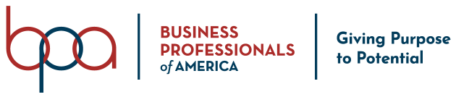

Social Media Responses

Should you be approved as an official National Officer Candidate, these social media responses will be posted prior to National Leadership Conference in order to allow student members to learn more about you and your platform.

- Each response to the questions listed below must be fifty (50) words or less.
- Microsoft Word should be used to generate your responses to ensure that the word count is consistent for all candidates.
- Use Century Gothic font / Size 11
- Any response(s) that exceed the fifty (50) word requirement will be cut-off at the fifty (50) word mark.
- You may choose not to respond to any/all questions, however, it will be noted that you chose not to respond.
- All responses must be submitted by April 1, 2021.

How would you describe your leadership style?

What are the most important values that you demonstrate as a leader?

What is your biggest accomplishment as a member of BPA?

What is the most important goal you wish to achieve in service as a National Officer?

How can you create a culture of collaboration in a virtual environment to ensure a successful team?

How do you approach conflict resolution?

Printed Name: _______________________________________ Date: ____________________

Signature: ____________________________________________

