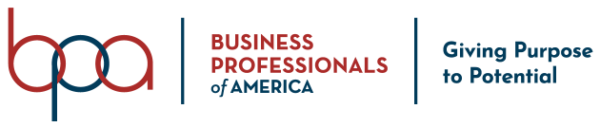

National Officer Code of Ethics

Should I be elected as a National Officer for Business Professionals of America, I understand that I must adhere to the Member Code of Conduct and Ethics as outlined in the National BPA Policies and Procedures Manual (Article XIII – page 40), as well as the specific National Officer Code of Ethics outlined below:

- To forego all alcohol while involved in official or assigned activities
- To forego tobacco while in official dress
- To consider romance of any type with other national officers as "off limits" during my year as national officer
- To be willing to take and follow instructions as directed by those responsible for them
- To wear official dress when traveling to an assignment and using public transportation
- To serve as a member of the officer action team by always maintaining a cooperative attitude
- To use wholesome language in all speeches and informal conversations
- To maintain proper dress and good grooming in all occasions
- To avoid places or activities which in any way could raise question as to moral character or conduct
- To avoid participation in and actively discourage any conversations which belittle or downgrade fellow members, officers, and/or adults
- To treat all members equally by not favoring one over another
- To behave in a manner which conveys and commands respect without any air of superiority
- To maintain dignity while being personable, concerned, and interested in fellow members
- To abide by the Delegate Conduct for all Business Professionals of America sponsored activities

I further understand that if I do not abide by the BUSINESS PROFESSIONALS OF AMERICA National Officer Code of Ethics, I may be relieved of my duty and the National Center will declare my office vacant.

Printed Name: _______________________________________ Date: ____________________

Signature: ____________________________________________

