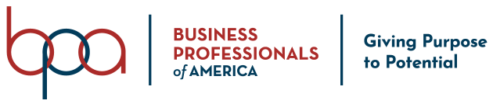
Statement of Understanding on Meeting Attendance

If elected as a National Officer for Business Professionals of America, I understand that attendance at all scheduled National BPA, Executive Council, sub-committee and all other meetings is required. Additionally, I understand that I must arrive on-time for each meeting and stay until the meeting has been adjourned. Furthermore, I understand that should I fail to adhere to these requirements, it will result in me being removed from office.

Note: The majority of our meetings throughout the membership year are completely virtual, so it is essential that you have access to reliable internet in order to attend and fully participate with your team. If you do not have internet access at home or through your cell phone provider, it is your responsibility to locate a place that can accommodate your needs (school, public library, coffee shop, etc.)

A few of these required meetings include, but are not limited to:

National Officer Training – Columbus, OH
- To Be Determined
  - Due to the ongoing COVID-19 pandemic, an in-person training is tentatively on-hold. We are continually monitoring this situation and will provide dates as soon as possible should we be able to host this training in-person.
  - Alternative virtual training will be held June 28 - July 1, 2021.
Executive Council Team Meetings
- Meeting cadence will be established at National Officer Training
- Average is one (1) meeting per week
- Each meeting typically lasts between 60 -120 minutes
2021 Student Leadership Summit
- Mid to late November
Winter Meeting – Dallas, TX
- Typically held the first week in January over the course of six (6) days
2022 National Leadership Conference – Dallas, TX
- May 1 – 8, 2022

Printed Name: _______________________________________ Date: ____________________

Signature: ____________________________________________

